PRACTICAL NO 6: Configuring a Zone-Based Policy Firewall (ZPF)
Cisco IOS® Software Release 12.4(6)T introduced Zone-Based Policy Firewall (ZFW), a new configuration model for the Cisco IOS Firewall feature set. This new configuration model offers intuitive policies for multiple-interface routers, increased granularity of firewall policy application, and a default deny-all policy that prohibits traffic between firewall security zones until an explicit policy is applied to allow desirable traffic.

We use the following Topology for the current case
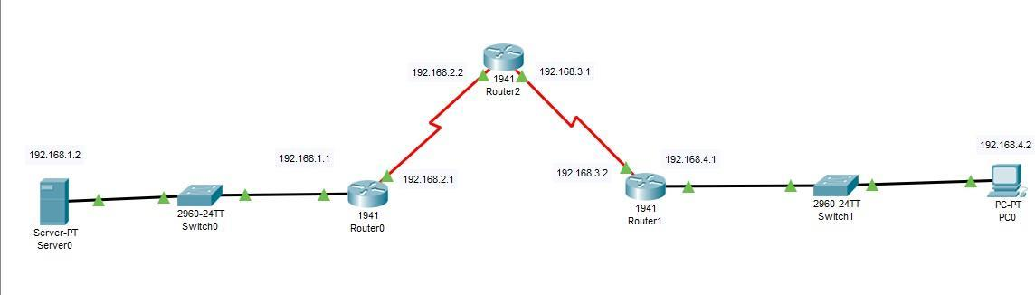
Configuring PC0
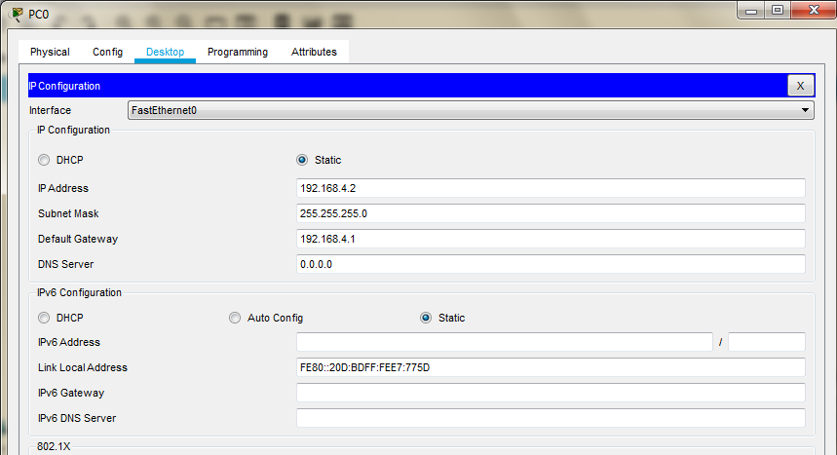

Serial Interface must be added in each Router before configuring it

Configuring Router0
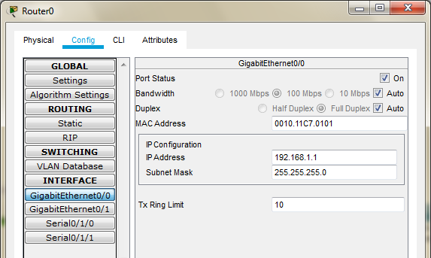
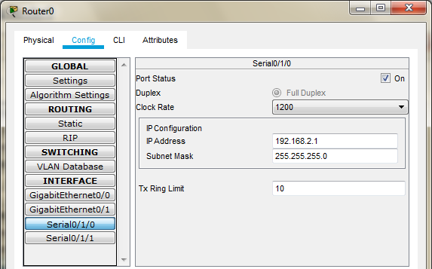

Configuring Router1
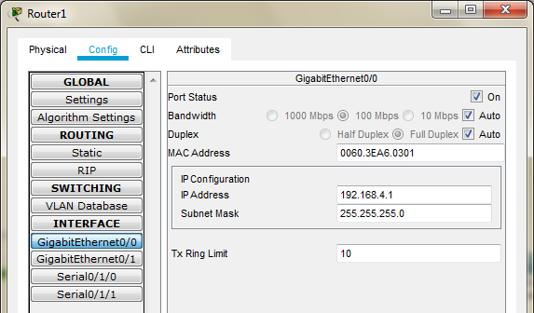
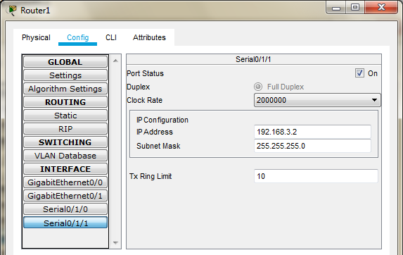

Configuring Router2
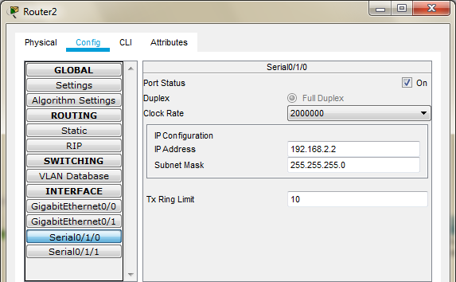
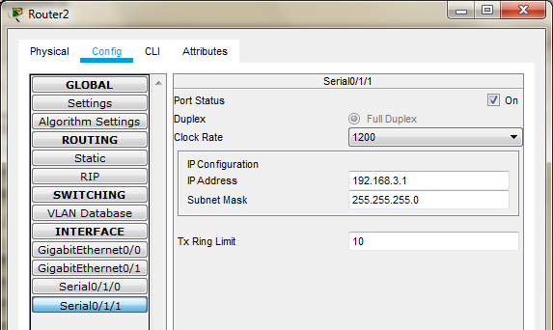

Configuring Server0
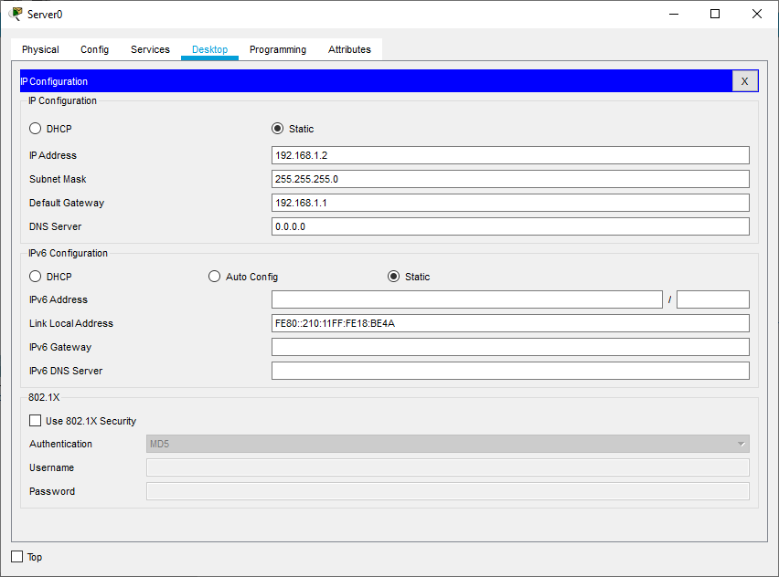

Part 1: Static Routing

Static Routing is done using the following procedure for each Router Router 2: Add the following Routes in the Static mode
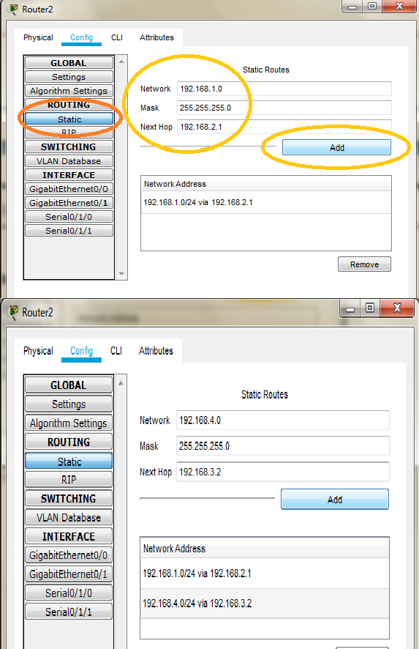

Router 0: Add the following Routes in the Static mode
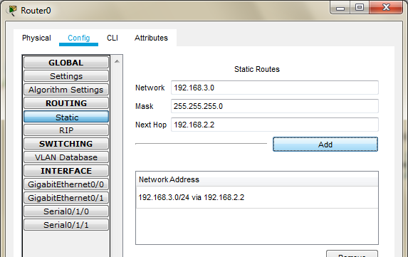
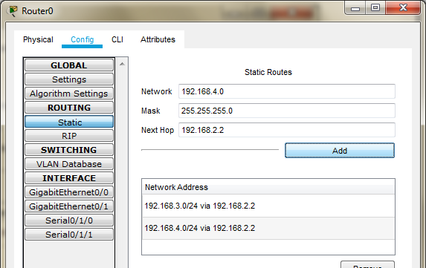

Router 1: Add the following Routes in the Static mode
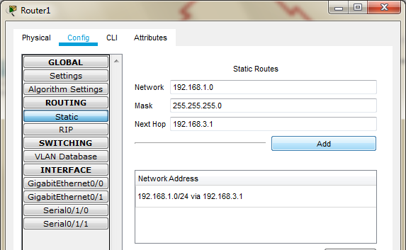
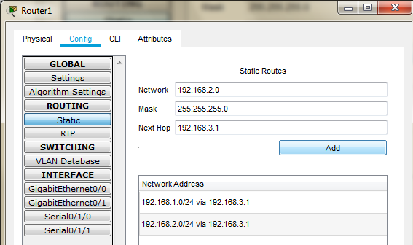

Now we check the connectivity by pinging the Server from the PC
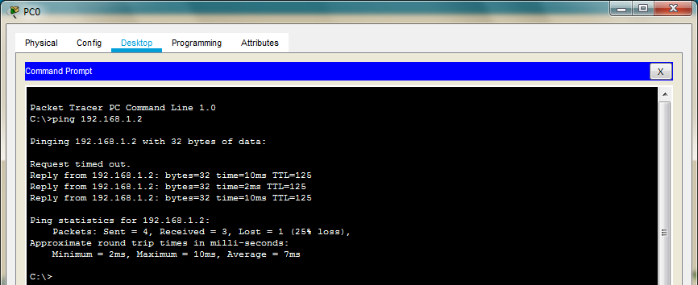

Part 2: Configuring SSH on Router 2

Type the following commands in the CLI mode of Router2

Router>en Router>enable
Router#configure terminal Router(config)#ip domain-name ismail.com Router(config)#hostname R2 R2(config)#cryp
R2(config)#crypto k R2(config)#crypto key g R2(config)#crypto key generate r R2(config)#crypto key generate rsa

R2(config)#line vty 0 4
R2(config-line)#transport input ssh R2(config-line)#login local R2(config-line)#exit
R2(config)#username ismail privilege 15 password cisco

Now we verify the SSH using PC as follows
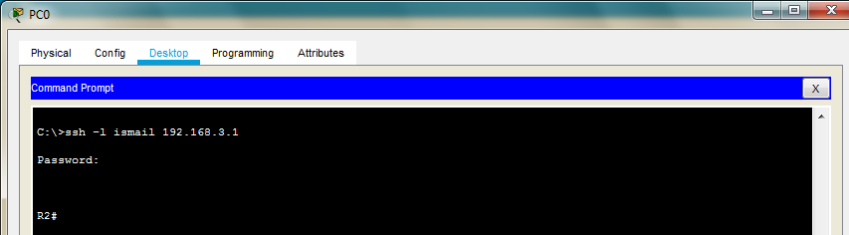

Next we access the web services of the Server using the web browser of PC using the following
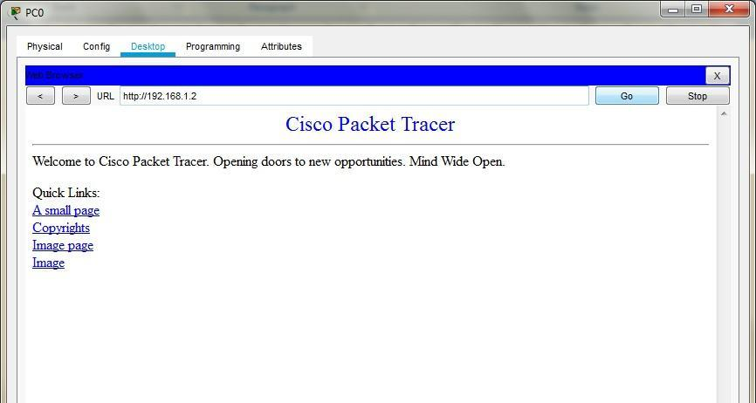

Part 3: Create the Firewall Zones on Router1

Type the following commands in the CLI mode of Router1

Router#
Router#configure terminal

Router(config)#zone security in-zone Router(config-sec-zone)#exit

Router(config)#zone security out-zone Router(config-sec-zone)#exit

Router(config)#access-list 101 permit ip 192.168.4.0 0.0.0.255 any Router(config)#class-map type inspect match-all in-map Router(config-cmap)#match access-group 101
Router(config-cmap)#exit

Router(config)#policy-map type inspect in-out Router(config-pmap)#class type inspect in-map Router(config-pmap-c)#inspect
Router(config-pmap-c)#exit Router(config-pmap)#exit Router(config)#

Router(config)#zone-pair security in-out-zone source in-zone destination out-zone Router(config-sec-zone-pair)#service-policy type inspect in-out
Router(config-sec-zone-pair)#exit Router(config)#

Router(config)#interface GigabitEthernet0/0 Router(config-if)#zone-member security in-zone Router(config-if)#exit
Router(config)#

Router(config)#interface Serial0/1/1 Router(config-if)#zone-member security out-zone Router(config-if)#exit
Router(config)#exit

Router#copy running-config startup-config

Part 4: Testing the Firewall Functionality (from in-zone to out-zone)by the following steps

Step 1: Pinging SERVER from the PC (it will succeed)
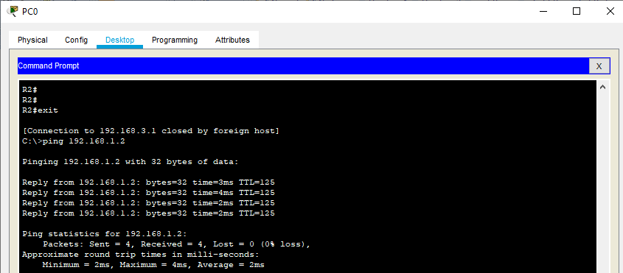

Step 2: Start an SSH session from PC to Router 2 (ip 192.168.1.2)
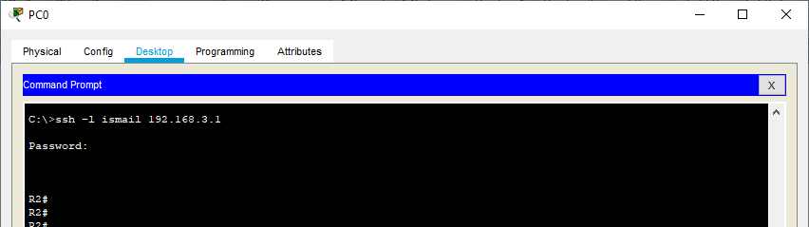

As seen above the session becomes active and we get access to Router2 (Do not exit and the session and continue to Step 3)

Step 3: Type the following command in the CLI mode of Router1

Router#show policy-map type inspect zone-pair sessions We will get the following output
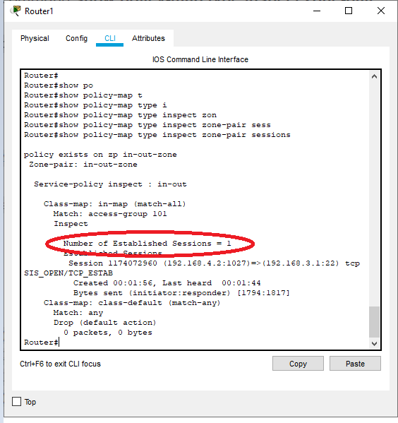

Step 4: We close the SSH connection and open the web browser and access the server address (192.168.1.2) and get the following
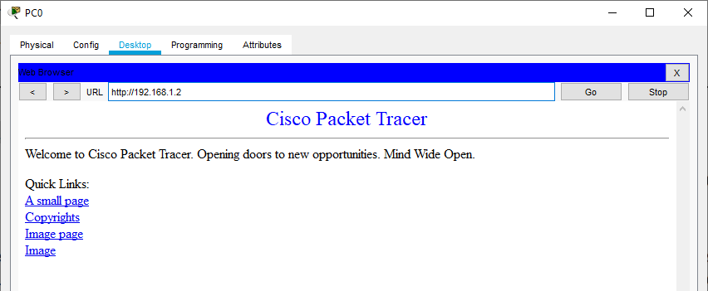

Part 5: Testing the Firewall Functionality (from out-zone to in-zone)by the following steps

Step 1: Ping PC0 from the SERVER (it will result in Failure)
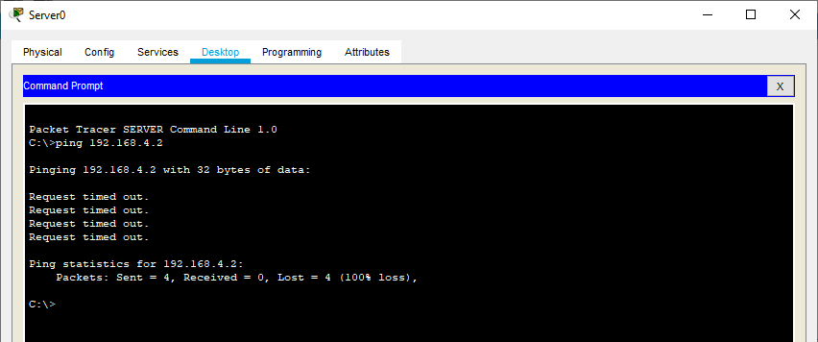

Hence the Firewall functionality has been verified

